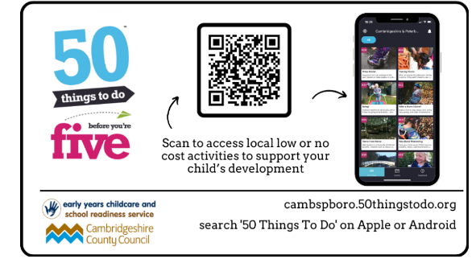


Week Beginning: 22nd September 2025

Thank you for all your support this week at home. The children have settled well and had a fantastic start to their reception journey. The EYFS team have enjoyed getting to know the children and welcoming them into Greenland and Lapland classes.

Next week, we will be learning about…
Topic:
We will be learning to greet people when we meet them e.g. ‘Good morning/afternoon’, ‘Hello, my name is….’
We will be exploring the story of ‘The Little Red Hen’ through music, storytelling and drawing!

Phonics:
This week we have been learning to recognise and form the letters s, a, t, and p. Next week, we will learn to recognise and form the letters i, n, m and d. We will focus on oral blending and trying to blend the sounds we hear.

Maths:
The children will engage with activities that draw attention to the purpose of counting – to find out ‘how many’ objects there are. We will also practise developing 1:1 correspondence, by counting numbers at the same time as moving or tagging the objects. Each week we will have a lesson which focuses on shape, space and measure. This week we will begin to create and copy repeated patterns.

How you could help your child at home:
- ‘What was good about your day?’ Focus on a positive aspect of their day.
- Practise oral blending – Talk to your child using sounds. Encourage them to repeat the sounds and then blend them together the make the word. i.e. ‘put on your c-oa-t.’ ‘It’s time to brush your t-ee-th’
- Spend some time sharing and discussing the wordless book that your child brings home today. E.g. What can you see? What will happen next?
- Provide baskets of mixed objects (up to 5 of each item) to sort – how many of each object have we got?
- Visit the QR code below for 50 exciting, open-ended ideas for play for children. Let us know if you try any!

Reminders:
- Please feel free to send in a pair of wellies to keep in school and a set of spare clothes if your child is prone to accidents or loves water play.
- Don’t forget, we are a citrus and nut free school, so please don’t pack these items in lunchboxes.
- Grapes in lunchboxes should be cut in half lengthways.

EYFS Team

yry1teachers@fulbourn.cambs.sch.uk

