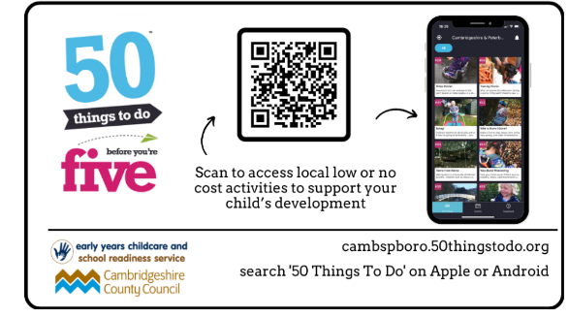


Week Beginning: 29th September 2025

Next week, we will be learning about…
Topic:
We will be retelling the story of ‘The Little Red Hen’. We will learn about Harvest and how it is celebrated. We will discuss the items we need to meet our everyday needs. We will explore colour mixing and printing using vegetables.

Phonics:
We will learn to recognise and form the letters g, o, c, and k. Using familiar sounds, we will learn to segment and blend CVC words. We will learn to recognise the tricky word ‘is’.

Maths:
We will explore how numbers can be composed of 1s and, from this, begin to investigate the composition of 3 and 4. Composing and de-composing numbers involves children investigating part–whole relations, e.g. seeing that 3 can be composed of 1 and 2. The children will learn from practical experience that a ‘whole’ is made up of smaller parts and is, therefore, bigger than its parts.

How you could help your child at home:
- Read with your child daily – Take it in turns to use the pictures in your child’s new wordless book to tell a story.
- Daily practise of the phonemes we have learnt so far – s, a, t, p, i, n, m, d
- Practise putting on shoes and socks as quickly and as independently as possible, to help speed up this process in PE lessons! You could practise using a hair scrunchie on your foot to begin with instead of a sock.
- When out for a walk notice when objects are grouped into 2s, 3s or 4s, e.g. adults can observe (e.g., I can see 3 bikes) so that the children see quantities and not just 'something'.
- Go for a walk and collect conkers and pinecones. How many did you find? Practise counting by moving or tagging the objects (1:1 correspondence).

Reminders:
- Please place reading records in your child’s book bag or backpack everyday as we will be writing notes in them when we read as a group. The day of the week might change.
- Please return reading books on a Friday so children can be given a new book.
- Please make sure that all jumpers are labelled with your child’s name. Don’t forget to rename second hand clothing.

EYFS Team

yry1teachers@fulbourn.cambs.sch.uk

