Ancient Greek Day – Thursday 19th September 2024

Dear Parents/Carers,
To complement our study of Ancient Greece, we have invited History Off the Page to provide a Life in Ancient Greece Day at school on Thursday 19th September 2024. The activities will run during the hours of the normal school day.
History Off the Page is a company which provides immersive and practical History, Science and Literature workshops to schools. Our workshop will give the children a feeling of what it was like to be a Greek in ancient times, during the 5th Century BC in Athens. The children will learn about the issues of the time, with the opportunity to participate in a range of cross curricular activities and crafts.
All children will need a costume on the day. History Off the Page suggest the following:

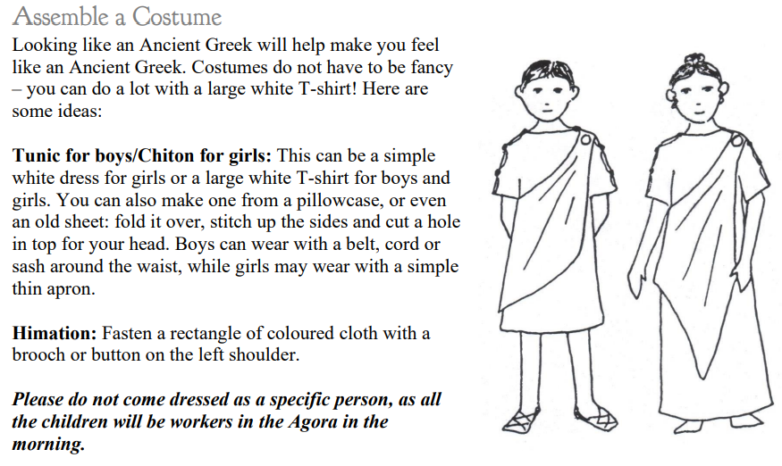

We also need a number of adult helpers during the day, who will need costumes too. Please email us at y5y6teachers@fulbourn.cambs.sch.uk if you are able to help.
Best wishes,
The Upper School Team

